Surgery on Sunday Louisville Consulting

Use Case Specification: Setup An Alert System For Patient Database

Version 3.0

Revision History

|  |  |  |  |  |
| --- | --- | --- | --- | --- |
| **Date** | **Version** | **Description** | | **Author** |
| 21/Oct/17 | 1.0 | Setup Alert System For Patient Database | Cody Higdon | |
| 6/Nov/17 | 2.0 | Setup Alert System For Patient Database w/ Prototypes | | Cody Higdon |
| 7/Dec/17 | 3.0 | Setup Alert System For Patient Database w/ Prototypes | | Cody Higdon |
|  |  |  | |  |

Table of Contents

1. Use-Case Name 4

1.1 Brief Description 4

2. Flow of Events 4

2.1 Basic Flow 4

2.2 Alternative Flows 4

2.2.1 < First Alternative Flow > 4

2.2.2 < Second Alternative Flow > 4

3. Special Requirements 4

3.1 < First Special Requirement > 4

4. Pre-conditions 4

4.1 < Pre-condition One > 4

5. Post-conditions 4

5.1 < Post-condition One > 4

6. Extension Points 4

6.1 <Name of Extension Point> 4

7. Class Diagram 5

8. Sequence Diagram 6

9. Use Case Diagram 7

10. Prototype 8

10.1 Prototype Description 8

10.2 Actual Prototype 8

Use Case Specification: Setup an Alert System for Patient Database

# Setup an Alert System

## Brief Description

The purpose of this use case is to setup an alert system for patient database. This is necessity to know when the clinic receives a patient. The alert system would allow Surgery on Sunday to see that a new patient has entered their database.

# Flow of Events

## Basic Flow

* IT Coordinator creates alert settings on Patient Database

## Alternative Flows

### There are no alternative flows for this use case.

# Special Requirements

## The alert system must be able to alert any device that has access to the system. This will improve the knowledge of new volunteers that come into the Patient database to help with future events. This will improve performance and knowledge of the employees creating events.

# Pre-conditions

## The IT Coordinator must have access to the organization’s system to set up the alert systems.

## The IT Coordinator logs on the system

# Post-conditions

## IT Coordinator logs off the system

## The alert system for Patients will be created on Patient Database.

# Extension Points

## There are no extension points for this use case.

# Class Diagram:

**IT Cordinator**

**Attributes:**

* **Alert Settings**

**Methods:**

**+ Create ()**

# Sequence Diagram



**Object:**

Patient Database

**Class:**

Alert System

IT

Cor.

Creates



# Use Case Diagram:



**UCID 079: Login to system**

**UCID 053: Delete Patient from Patient Database**

**UCID 054: Alert for Patient Database**

**UCID 051: Add Patient to Patient Database**

**UCID 052: Edit Patient in Patient Database**



Admin

SOSL Employee

**UCID 042: Check Alert**

# Prototype:

Select Start & This will walk-through alert settings on this database

## Prototype Description: This Prototype will be used to set up Alert System for Patient Database. This will alert system will help notify SOSL of a new Patient.

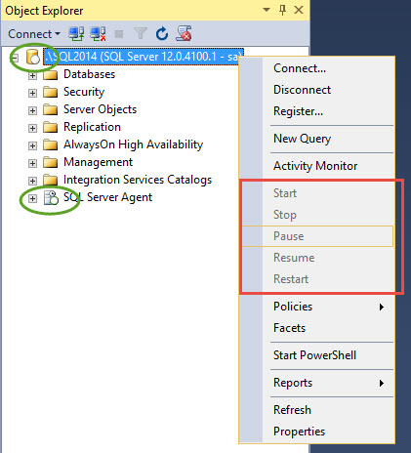**10.2 Actual Prototype:**